|  |
| --- |
| **Argentis Consulting** |
| **Apparel & Footwear** |
| Quick Style Creation |

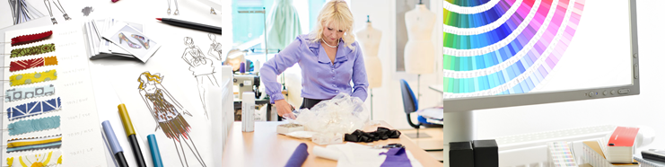

**www.sapapparel.com**

Quick Style Creation

Table of Contents

Quick style creation – SKU Generation 3

Quick style creation – Import from Excel procedure 4

## Quick style creation – SKU Generation

The quick style creation serves as a simple tool to create styles and SKUS, usually when receiving catalogs from suppliers or avoiding to open the product data management to add manually styles. The new version now supports the creation of SKUs, allowing customer to migrate critical data from the SAP interface and not using the standard DTW.

In the same process the user can add the styles and generate all skus.

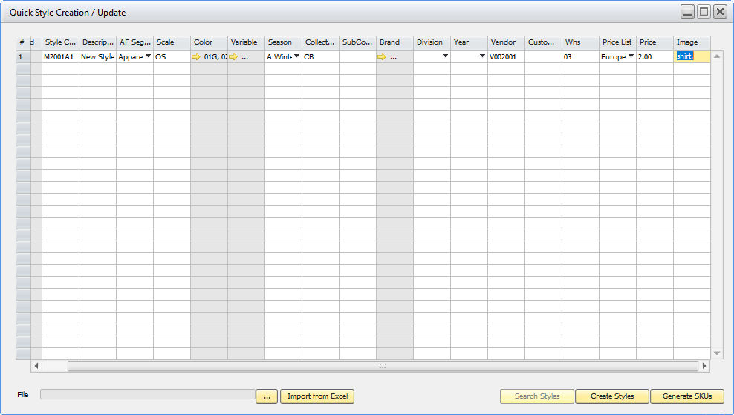

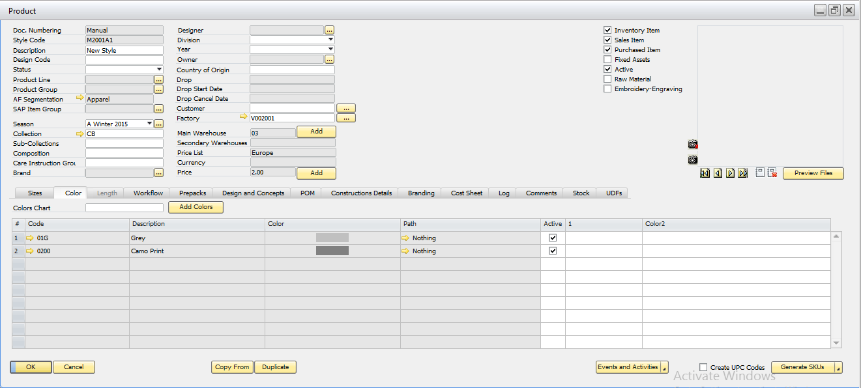

In future version the wizard will allow to update styles/skus

## Quick style creation – Import from Excel procedure

The excel *A&F - Quick Style Creation Example - References* will serve as an example how to fill the information in order to update into the system

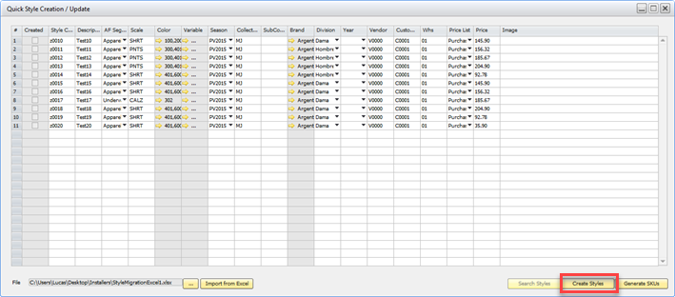

Once the file is imported, the next step is to create the styles and later on the SKUs

